SECOND TERM E-LEARNING NOTE

SUBJECT: AGRICULTURAL SCIENCE CLASS: SS3

SCHEME OF WORK

WEEK TOPIC
1. Agricultural Marketing.
2. Routine Management Practices in Farm Animals
3-4. Principles of Animal Health Management
5-6. Symtoms, Effects, Transmission and Control of Selected Diseases
7-8. Livestock parasites
9. Practical classes
10. General revision
11-12. Mock Examination

REFERENCES
- Essential Agricultural Science for Senior Secondary Schools by O. A. Iwena.
- Comprehensive Agricultural Science by Ogieva Erebor.
- Prescribed Agricultural Science by Omoruyi and Oruhue.
- Waec Pack.
- Internet (Pinterest, Wiki answer, FAO et al).

WEEK ONE
TOPIC: AGRICULTURAL MARKETING
CONTENT
- Meaning of agricultural marketing
- Importance of agricultural marketing
- Channels of marketing farm products
- Stages of agricultural marketing
- Agents of agricultural marketing
- Problems of agricultural marketing

MEANING OF AGRICULTURAL MARKETING
These refer to all the activities required or involved in moving farm produce from the producers to the final consumers. Production is not complete without consumption and marketing is what makes it happen.

IMPORTANCE OF AGRICULTURAL MARKETING
- Helps to make products available year round.
- It creates employment for people (drivers, traders, retailers etc).
- It locates where there are surpluses of produces and bring them to where there are shortages.
- It brings about foreign exchange to the nation through exportation of produce.
- It helps in price determination.
- It enables the producers to know the taste of the consumers.
- It initiates research into products preferred by consumer
- It helps in the provision of infrastructure such as roads, electricity, pipe borne water etc.

CHANNELS OF MARKETING FARM PRODUCTS
This refers to all the linkages or pathways through which farm produce pass through before they get to the final consumers. These include
- Producers
- Marketing board
- Local Market
- Middle men
- Co-operative societies
- Middlemen
- Commissioned agents
- Exporters
- Processor

STAGES OF AGRICULTURAL MARKETING
The Stages involves in marketing agricultural produce include
- Farm level processing
- Grading or sorting
- Packaging
- Storage or warehousing
- Transportation
- Advertisement
- Merchandizing
- Assemblage

EVALUATION
- What is agricultural marketing?
- What are the significance of agricultural marketing
- List and explain the stages of agricultural marketing.
- What are the channels involved in marketing of agricultural produce.

MARKETING FUNCTIONS
These are activities expected of a marketer in order to achieve set marketing objectives. The functions are:
- Researching
- Buying
- Product development and management
- Production
- Promotion
- Standardization and grading
- Pricing
- Distribution
- Risk bearing
- Financing

AGENTS OF AGRICULTURAL MARKETING
This includes all the people or agents or bodies which are directly or indirectly involved in the marketing of farm produce. These agents include:
- Marketing / commodity boards
- Co-operative societies
- Individual / Private Middlemen
- Producers / farmers
- Wholesalers
- Retailers

MARKETING/COMMODITY BOARDS
These are trading agencies of the government that oversee the marketing of export or cash crops. It started as marketing board and later changed to commodity boards.

ADVANTAGES OF MARKETING / COMMODITY BOARDS
- It creates employment for licensed buying agents.
- Guarantees producers prices and ensures production of export crops.
- They stabilize prices and ensure that farmers are not affected by price fluctuation.
- Encourage the processing of export produce.
- Generate income to the government through export duties and sales taxes.
- Contribute in providing social amenities like roads, hospitals, pipe-borne water etc.
- Promote produce quality.
- Encourage the production of both export and food crops.
- They sometimes provide capital to farmers.

DISADVANTAGES OF MARKETING / COMMODITY BOARDS
- It deals mainly on major export crops.
- They fix prices on their own without consulting the farmers.
- Middlemen cheat the farmers by either paying them lower prices or down grading their produces.
- When the world prices of produce rise, farmers are still paid the fixed prices
- Government interferes with the running of the boards.

CO-OPERATIVE SOCIETIES
There are voluntary organization formed by a group of individuals who pool their individual resources together with the primary objectives of satisfying the needs and aspirations of their members.

ADVANTAGES OF CO-OPERATIVE SOCIETIES
- Purchase commodities in bulk from the producers.
- By pass the middlemen, and deal directly with producers as a result, they retail commodities to the members and non-members at moderates prices.
- Members pool individual resources together to meet special needs of members which on individual’s basis is difficult.
- The profits of the co-operatives are shared among the members either according to the individuals share holdings or volume of purchase from the co-operative.
- Membership is voluntary.
- They provide storage facilities.
- They grant loan to members.
- They provide transportation facilities.

DISADVANTAGES OF CO-OPERATIVE SOCIETIES
- Poor and ineffective management.
- It is prone to financial misappropriation.
- It does not encourage establishment of individual enterprise.

PRODUCERS
These are the farmers who produce agricultural commodities.

ADVANTAGES OF PRODUCERS
- Agricultural market starts with the farmers without whom the existence of other marketing agents and consumers is meaningless
- They produce what consumers need thereby satisfying their taste and preference.
- Produce gets to consumer at reduced rice.
- Produce get to the consumer in its fresh state.

DISADVANTAGES OF PRODUCERS
- The producers through the producers co-operative may decide to produce what will attract higher income to them and not what the consumers need most.
- They hoard and ration the supply of produce to the market in order to enjoy attractive prices.
- He lacks storage facilities.
- Farmers may suffer increased loss of goods.
- He lacks transportation facilities.

INDIVIDUAL / PRIVATE MIDDLEMEN
These are individuals that come directly to the farm to buy farm produce.

ADVANTAGES OF PRIVATE MIDDLEMEN
- They link producers with consumers.
- They may give loans to producers.
- They assemble, blend and repack certain goods.
- They save the producer’s time in marketing his goods.
- They also provide storage facilities.
- They also provide transport facilities.

DISADVANTAGES OF PRIVATE MIDDLEMEN
- They inflate the prices of commodities.
- They create artificial scarcity of goods.
- They exploit producers and consumers.

WHOLESALER
These are the agents who buy produce in large quantities from the farmers (producers) and sell in small quantity to the retailers.

ADVANTAGES OF WHOLESALER
- They purchase produce in bulk.
- They provide storage facilities.
- They have good transport facilities.
- They pass information from retailer to producers and vice versa.

DISADVANTAGES OF WHOLESALERS
- They exploit the producers and retailers.
- They create artificial scarcity of goods.
- They inflate the prices of commodities.

RETAILERS
These are agents who buy goods from the wholesalers and sell in small quantities to the final consumers.

ADVANTAGES OF RETAILERS
- They make produce readily available and affordable to consumers.
- They provide jobs to many people.
- They pass information from consumers to wholesalers.
- They give credits to some consumers.

DISADVANTAGES OF RETAILERS
- They may create artificial scarcity of goods
- They may suffer losses due to theft or spoilage of perishable goods
- They may inflate the prices of commodities.

PROBLEMS OF AGRICULTURAL MARKETING
- Inadequate transportation system.
- Small scale production.
- Inadequate basic amenities.
- Perishability of produce.
- Inadequate storage facilities.
- Inadequate processing facilities.
- Poor financing.
- Poor Prices of products.
- Problems of middlemen.
- Difficulty in assembling produce.

POSSIBLE SOLUTION TO PROBLEMS OF AGRICULTURAL MARKETING
- Provision of good roads.
- Provision of finance to farmers.
- Provision of storage and processing facilities.
- Formation of good policies by the government.
- Encouragement of market research.

EVALUATION
- What are the agents of marketing?
- What are the problems of agricultural marketing?

GENERAL EVALUATION
- What is agricultural marketing?
- What are the importance of agricultural marketing?
- List ten problems of agricultural marketing.
- List five possible solutions to the problems of agricultural marketing.
- What are marketing functions?
- List and explain six marketing functions.

READING ASSIGNMENT
Essential agricultural science for senior secondary school by O. A. Iwena pages 450 – 458
Answer revision questions 2 and 13 on page 458.

WEEKEND ASSIGNMENT
- Which of the following is not an agricultural marketing agent in Nigeria? (a) Consumers (b) co-operative society (c) Producer (d) consumers
- Establishing a specified characteristics that your product must conorm to is ____
(a) sorting (b) pricing (c) standardization (d) promotion
- ____ buys produce from farmers in raw state and coverts them to usable or consumable forms (a) Middle men (b) Marketing board (c) Processors (d) Wholesalers
- The disadvantage of buy produce directly from farmers is (a) the produce are usually at the freshest state (b) produce price is at the cheapest (c) produce are purchased at inflated prices if there is scarcity (d) none of the above
- ____ enables a marketer generate adequate information about targeted market
(a) Research (b) Sorting (c) Standardization (d) Promotion

THEORY
- State two advantages each of the following agricultural marketing agents.
  - commodity boards (ii) co-operative society (iii) middlemen (iv) Retailer
(v) producer.
- Explain the term marketing channel.
- Outline and discuss channels of marketing cocoa.
- List five ways by which marketing can be encouraged

WEEKTWO
ROUTINE MANAGEMENT PRACTICES OF FARM ANIMALS
CONTENT
- Selection
- Culling
- Identification of farm animals
- De-beaking
- De-horning
- Castration
- Servicing
- Incubation
- Candling
- Hatching

SELECTION
Selection is the process of picking from a group of animals those animals with breeding value as the parent to maximize genetic gain. Animals with desirable characters like good meat production, egg laying abilities, resistance to diseases, excellent mothering abilities, good milk producers etc are selected. Selection is grouped into two main classes.
- Natural selection: This is the ability of an individual animal to survive and reproduce during unfavourable environmental conditions. Those that are unable to survive die off.
- Artificial selection: This type of selection is carried out by man through close monitoring of the animals. The man uses his intelligence to select and mate animals. Four types of artificial selection include
- Mass selection: Animals with desirable characteristics are selected in preference to those not possessing them from a large group of animals.
- Progeny selection: The animals are selected based on the performance of their offspring. Best mothers are retained.
- Family selection: The animals are selected based on the performance of their relatives. It is useful when the family is large and heritability is low.
- Pedigree selection: The animals are selected based on the performance of their ancestors. It is based on heredity.

ADVANTAGES OF SELECTION
- It ensures that animals with desirable qualities are selected.
- Animals from best breeds are bred for distribution.
- It reduces the spread of diseases and parasites associated with breeding stock.
- It increases the rate of reproduction and yield.
- It reduces the cost of management.

DISADVANTAGES OF SELECTION
- Labour requirement is high.
- It is time consuming.
- It requires expertise which may not be readily available.
- It brings about the elimination of some desirable traits.

EVALUATION
- Differentiate between progeny and pedigree selection.
- Mention five importance of selection

CULLING
Culling is the removal of undesirable or unproductive animals from the farm. It may take the form of mass culling when the entire flock is removed e. g. old layers or selective culling when one or more animals are removed. Culling is done for the following reasons
  - Failure to reproduce or low rate of reproduction.
  - Ill health
  - Cannibalism
  - Low eggs production in poultry.
  - Fighting among animals.
  - Pronounced deformation of parts of the body.
  - Over weight due to excessive fat.

ADVANTAGES OF CULLING
- It reduces the cost of production.
- It reduces the cost of maintenance (feeding, health).
- It ensures greater production of animals.
- It ensures elimination of animals with undesirable qualities.
- It controls bad habits or vices from spreading to other animals.
- It creates space for the comfort of other animals.
- It controls diseases from spreading to other animals.

EVALUATION
- What is culling?
- Give five reasons for culling in a animal farms

IDENTIFICATION OF FARM ANIMALS
Identification of farm animals is essential for farmers to prove ownership, accurate recording and proper management of animals. Most common methods of identifying farm animals include branding, tattooing, ear-notching, chaining, nose punching etc.
- Branding: - It is a special marks in form of letters, numerals, designs make on some parts of the body of farm animals such as cattle, sheep, goat and pig. It is easy and cheap to carry out but it may be painful to animals and it can cause infections and death. It is usually carried out on horns, cheeks, body sides, thigh, shoulder, ore legs or below the shank. It could either be done with the use of heat generating machines (hot branding) or cold generating machine (cold branding). The cold branding is painless to the animal but more expensive for the farmer.
- Tattooing: - It is the piercing of outlines of desired numbers and letters made from metal pins on the skins or ears of farm animals and then incorporate a black pigment into these punctures. It is easy and cheap to carry out but can easily tear off the skin of farm animals.
- Ear-notching: - It is the practice of making small cuttings (a common code) on the ears of farm animals such as goat, cattle, sheep and pig. It is one of the best, cheap and most satisfactory methods of identifying farm animals.

DE-BEAKING
It is the partial removal of beaks of birds using a debeaker. De-beaking is done to prevent pecking of other animals, egg eating, cannibalism and feather removal. It should be done carefully to prevent stress and permanent damage to the beak and tongue of the birds.

DE-HORNING AND DISBUDDING
De-horning is the removal of horns of mature farm animals while disbudding is the removal of young horns from young animals using hot iron, saw, chemical or electric dehorner. It makes handling of farm animals easier. It prevents injuries to the body of other farm animals and prevents secondary infections caused by horn injuries. It must be carefully done to prevent injuries and infections to the animals.

EVALUATION
- Differentiate between tattooing and branding
- State three reasons each for i) de-beaking ii) de-horning

SERVICING
This is the mating of a male animal with a female animal identified to be on heat. The breeder should watch out for signs of heat in the female animal. Natural mating such as flock, pen and stud mating can be employed.

CASTRATION
Castration is the removal of testes in male animals. It is done in animals that are not required for breeding purposes. Castration is carried out when animals are young by open incision, buddizzo or rubber rings. It prevents indiscriminate mating, quickens the fattening up of the animals and the quality of meat. It also makes the animals to be calmer and easy to handle. It causes pain to the animal and infections if not properly treated.

INCUBATION
Incubation is the keeping of fertilized eggs warm so that the embryo will develop to produce young birds. Fertilized eggs are incubated for 21 days using incubators which supplies adequate temperature, ventilation and relative humidity until the eggs are hatched. The eggs are turned regularly to expose all sides to the incubator conditions.

CANDLING
This is the process of passing light through set eggs to identify and separate fertile eggs from unfertile ones. It is usually carried out on the 6th and 18th day of incubation.

Other management practices includes brooding, weaning, flushing, steaming up, creep feeding

EVALUATION
  - Define i) servicing ii) candling iii) incubation in poultry
  - What is castration? Give three importance of castration.

READING ASSIGNMENT
Essential Agricultural Science for senior secondary school by I. O Iwena chapter 46, pages 423 – 431.
Answer revision questions 2 and 8 on page 431.
Prescribed Agricultural Science chapter 5, page 279, 303, 319, 321

WEEKEND ASSIGNMENT
- Which of these is not a method of identifying farm animals a) chaining b) tattooing c) candling d) ear-notching
- The following are routine practices in poultry farm except a) incubation b) brooding c) tattooing d) de-beaking
- Identification and removal of unfertilized eggs from the incubator is aided with the use of as a) candler b) culler c) hatcher d) incubator
- Which of these is not a reason for carrying out selection in animal farms a) good meat production b) resistance to diseases c) maximize genetic gain d) cannibalism
- The following except one are factors to be considered in incubation a) feeding
b) temperature c) relative humidity d) Air flow

THEORY
- State three advantages and disadvantages of selection in farm animals.
- Describe briefly three routine practices in cattle management
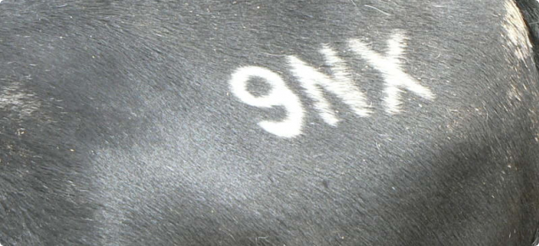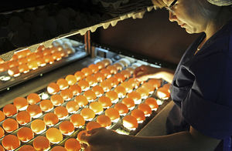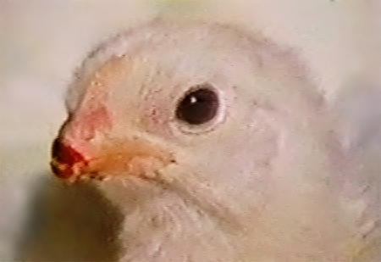
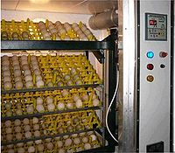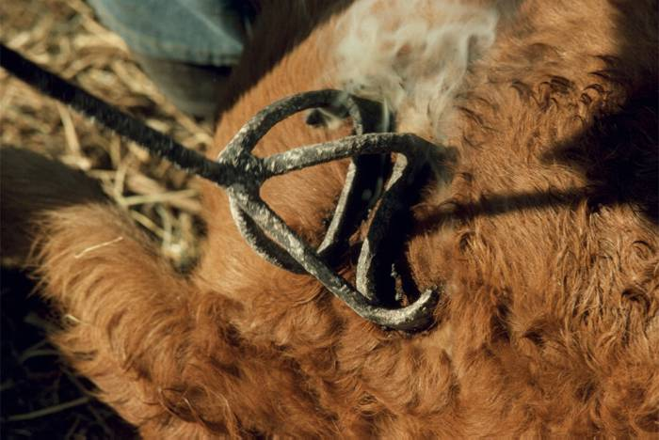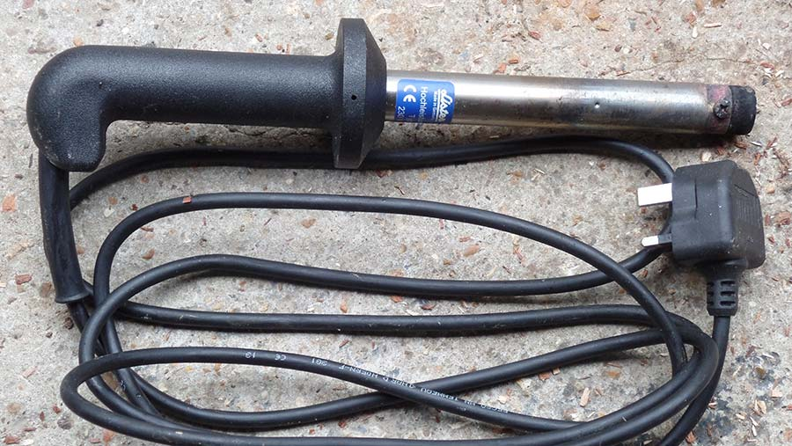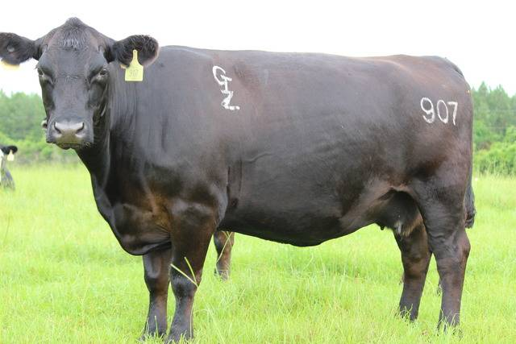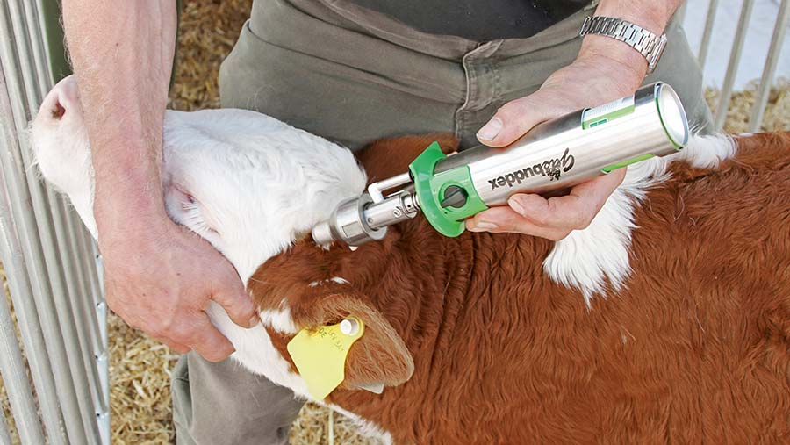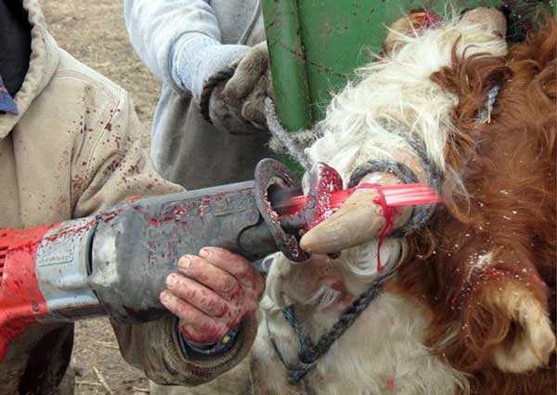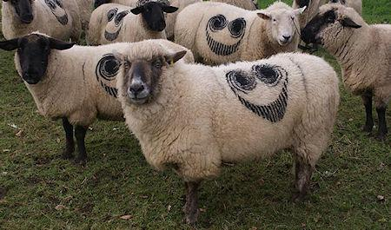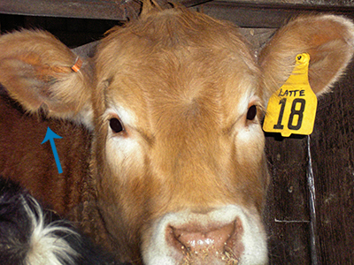

WEEK THREE AND FOUR
PRINCIPLES OF ANIMAL HEALTH MANAGEMENT
CONTENT
- Definition of Disease
- Classification of animal diseases
- Susceptibility and resistance to disease
- Factors that could predispose animals to diseases

LIVESTOCK DISEASES
Diseases in animal means any condition in which there is deviation from normal state of health or when there is any interference with the body processes which will make its body not to function in a normal way. This always give rise to ill health, which do not allow the animal to perform less in areas of live weight gain, milk production, work done in case of work animals, egg or wool production etc.
Animal diseases are generally caused by viruses, bacteria, fungi, protozoa and malnutrition.

CLASSIFICATION OF ANIMAL DISEASES
On the basis of organisms that cause diseases, the prevalent diseases of livestock can be grouped into
- Viral diseases
- Bacterial diseases
- Fungal diseases
- Protozoan diseases
and
- Malnutrition or metabolic disorder.

SUSCEPTIBILITY TO DISEASES
This refers to a condition in which the animal is easily attacked or infected by disease.

FACTORS THAT COULD PREDISPOSE ANIMALS TO DISEASES
The factors which help in initiation and continuation of disease condition include:-
- Health status of the animal:- Animals that are unhealthy can easily get infected more than those healthy animals.
- The farm environment:- Dirty and unhygienic environment could easily predispose animals to diseases.
- Nutrition:- Animals that are not fed properly in terms of quality and quantity can easily be infected by diseases.
- Management:- Animals that are not properly managed in terms of administration of drugs and vaccines appropriately could easily get attacked by disease.
- Unfavourable climatic conditions:- Extreme of climatic conditions such as rainfall, temperature, wind etc could predispose animals to disease attack.
- Poor Housing:- If animals are not properly housed and are exposed to heavy rainfall and high temperature, they could easily be attacked by diseases and parasitic infestations can also break out.
- Stress Conditions:- Conditions or pressures caused by difficulties in life can predispose animals to disease attack.
- Breeds of animals:- Poor breeds of animals can easily be prone to disease attack as against the good breeds.

RESISTANCE TO DISEASES
Disease resistance is the ability of the animal to withstand the attack of by a pathogen and remain healthy.
FACTORS THAT DETERMINE RESISTANCE OF ANIMAL TO DISEASE
- Development of immunity
- Species of animal
- Inoculation
- Level of feeding
- Age of animal
- Physiological condition of the animal

EVALUATION
- Define livestock diseases.
- Define immunity

ECONOMIC IMPORTANCE OF ANIMAL DISEASES
- Poor growth is achieved
- Poor food utilization
- Low yield of productivity.
- Low income to expecting farmer
- Poor quality of animal products
- Death of livestock

METHODS OF PREVENTING DISEASES
1. Quarantine - New stock being brought to the farm should be separated from the animals originally on the farm for proper scrutiny.
2. Vaccination - Farm animals should be vaccinated at the right time and doses to give them immunity against pathogenic organisms.
3. Hygiene - Good hygiene must be taken to prevent infection of farm animals. This involves cleaning of pens, watering and feeding equipment, disposal of waste and regular disinfection.
4. Good feeding - Animals should be properly fed in order to resist diseases attack.
5. Breeding - Diseases resistant stocks should be bred on the farm.
6. Rotational grazing - It makes building up of parasites to be avoided.
7. Isolation - All sick animals should be isolated from healthy ones.

EVALUATION
- Explain Quarantine
- Explain rotational grazing

GENERAL EVALUATION
- State the economic importance farm animal diseases
- What is disease resistant?
- What is susceptibility to disease?
- List four classes of animal disease
- List three factors that determine resistant to diseases.

READING ASSIGNMENT
Essential Agricultural Science for senior secondary schools by O.A. Iwena, Chapter 30, Page 383-386. Answer revision questions 11 and 14 on pages 396 and 397

WEEKEND ASSIGNMENT
- An effective way of ensuring built in resistance to disease in calves is to a) vaccinate calves at weaning b) allow calves access to colostrums c) ensure regular veterinary check-up d) observe proper quarantine e) give balanced diet
- Disease causing organisms are referred to as a. vectors b. pathogens c. pests d. insect
- Animal diseases are generally caused by the following except a. protozoa b. nematode c. virus d. fungi
- An animal is said to be resistant to a disease if the a. animal easily succumb to infection by the disease. b. presence of the disease pathogen does not cause expression of disease symptoms. c. animal is able to endure the effect of the disease. d. animal has no antibodies in its blood.
- The factors that can predispose animals to diseases include the following except
a. poor housing b. immunity c. malnutrition d. unfavourable weather

THEORY
- What is livestock disease?
- Briefly explain four factors that could predispose animals to diseases.
- List ten common symptoms of animal disease.

WEEK FIVE AND SIX
TOPIC: SYMPTOMS ,TRANSMISSION, EFFECTS, PREVENTIVE AND CURATIVE CONTROL OF ANIMAL DISEASES

VIRAL DISEASES
CONTENT
- Foot and mouth disease
- Rinderpest diseases
- Newcastle disease
- Fowl pox
- Gumburo disease

VIRAL DISEASE | ANIMAL AFFECTED | MODE OF TRANSMISSION | SYMPTOMS | CONTROL/PREVENTION
FOOT AND MOUTH DISEASE | Cattle, Sheep and Goat | contact, air-borne, droplets of saliva, infected materials like urine, faeces. | Formation of blisters (skin vesicle filled with serum, watery animal fluid) on the skin, between and around the hooves, inflammation of teats and udder, salivation, loss of weight. | Isolation of infected animals, burning or burying contaminated materials, timely vaccination.
RINDERPEST DISEASE | Cattle, Sheep and Goat | By contact, contaminated feed and water | High fever, weakness, difficult breathing, blood stained diarrhoea, high mortality, loss of appetite. | Timely vaccination, isolation of infected animals, restriction of infected animal movement within the farm.
NEWCASTLE DISEASE | Domestic fowl, Turkey, Goose, Ducks and Guinea fowl | Through contaminated feed, water and litter | Sneezing, nasal discharge and difficult breathing. Lack of appetite and diarrhea, Paralysis, somersaulting, twisting of neck, cycling movement | Vaccination, good sanitation, disinfection of poultry building.
FOWL POX | Fowl | Through contaminated feeds, water and litter materials | Sores on the combs and wattles | Isolate the infected birds, practice good sanitation measures, apply iodine on the affected parts, adopt routine vaccination
GUMBURO DISEASE | Birds | Through faecal, contaminated feeds, water and litter. | Swelling of liver, spleen and kidney. The birds appear dull and sleepy. | Isolate infected birds to maintain good sanitation measure, adopt routine vaccination.
EVALUATION
- a. Name the causative agent of Newcastle disease
b. What are the symptoms?
c. How can it be controlled?
- Name 5 viral diseases.
- State the symptoms of fowl pox.
- State the mode of transmission of fowl pox
- List two animals that are affected by rinderpest

READING ASSIGNMENT
Essential Agricultural Science for senior secondary schools by O. A. Iwena, page 383 - 386

WEEKEND ASSIGNMENT
- The best control measure for rinderpest disease in cattle is a. sanitation b. isolation
c. eradication of infected stock d. vaccination
- The part of the body affected by newcastle disease of poultry are the a. nervous system and respiratory tract b. digestive and circulatory system c. reproductive and excretory tracts d. air sac and the comb
- The general symptoms of malnutrition in animals include the following except
a. retarded growth b. increase in body size c. low production d. susceptibility to disease.
- Newcastle disease affects the following animals except a. goat b. chicken c. turkey
d. duck
- Which of the following is not a viral disease? a. Anthrax b. Fowl pox c. Gumburo
d. Rinderpest.

THEORY
Consider the following viral diseases
  - Foot and mouth
  - Rinderpest
  - Newcastle
- Name three animals that can be affected by each of the disease listed above.
- State two major symptoms each of them.

BACTERIAL DISEASES
CONTENT
- Anthrax
- Brucellosis
- Tuberculosis
- Pullorum Disease
- Fowl Typhoid
- Fowl Cholera

BACTERIAL DISEASE | ANIMAL AFFECTED | MODE OF TRANSMISSION | SYMPTOMS | CONTROL/PREVENTION
Anthrax  Bacillus anthraxis | Cattle, Sheep, Goat, Pig. | Through contaminated feed, water, equipment and infected animals. | High fever, depression, staggering and sudden death of the animal. | No effective drug for the treatment. Regular vaccination, infected animals should be slaughtered and buried, proper sanitation.
Brucellosis (Contagious abortion) Brucella abortus | Pigs, Cattle, Sheep and Goat. | Contaminated feed, water, contact with infected animals, contact with infected materials such as shoes etc. | Abortion, inflammation of the womb, diarrhoea and dysentery, paralysis, loss of  milk and frequent infertility. | Sick animals should be isolated and badly infected animals should be killed and  burried.
Tuberculosis Mycobacterium tuberculosis | Cattle, Sheep, Goat, Pigs and poultry birds. | Sputum, droppings, milk of infected Cow, germ inhaled or through  mouth during feeding | Constant coughing, loss of weight and appetite, infection of liver and udder in  Cows. | No cure of drug. Animal infected should be killed and buried, good sanitation, isolate suspected  animals.
Pullorum Disease | Poultry | Through contamination of feeds, water and litter | Watery droppings that are usually sticky and greenish - white in colour. | Obtain chicks from sources that are disease free, Isolate infected birds, Maintain good sanitation, Treat the infected birds with appropriate antibiotics.
Fowl Typhoid | Fowl | Through contaminated feed, water and litter materials | Yellowish watery droppings, loss of appetite and ruffled appearance. | Routine vaccination, Maintain good sanitation, Treat the infected birds with appropriate antibiotics
Fowl Cholera | Fowl | Through contaminated feed, water and litter. | Ruffled appearance, thirst due to dehydration, blood-stained yellowish watery droppings and sudden death. | Isolate infected birds,  Maintain good sanitation measures,  Practice routine vaccination and treat the infected birds with appropriate antibiotics.

EVALUATION
    - List five bacteria diseases
    - List three animals that are affected by brucellosis

FUNGAL DISEASES
CONTENT
- Ringworm
- Aspergillosis

FUNGAL DISEASE | ANIMAL AFFECTED | MODE OF TRANSMISSION | SYMPTOMS | CONTROL/PREVENTION
RINGWORM | Cattle Sheep, Goat and Rabbit | Contact with contaminated feeders and water troughs | Lesions (injury, damage, change in texture) in the skin of the animals, irritation  of the skin, loss of appetite and weight. | Disinfection of pens and equipment, treat affected parts with sulphur ointment.
ASPERGILLOSIS Aspergillus fumigatus | Poultry birds, pigs, Cattle | Through contaminated feed (mouldy feed), mouldy litter. | Difficult breathing, respiratory disorder, loss of appetite, irritation of skin, high body temperature, loss of weight. | Regular disinfection of the pen and equipment, avoid use of mouldy feed, practice good sanitation and maintain proper hygiene, spray fungicide from time to time to kill fungi spores.

EVALUATION
- List three fungal diseases
- State the symptoms of ringworm

PROTOZOAN DISEASES
CONTENT
- Trypanosomiasis
- Coccidiosis
- Red water fever (Piroplasmosis)

PROTOZOAN DISEASE | ANIMAL AFFECTED | MODE OF TRANSMISSION | SYMPTOMS | CONTROL/PREVENTION
TRYPANOSOMIASIS | Cattle, Sheep and Goat | Spread by the blood sucking Tse-tse fly which sucks blood from an infected animal and transmit the pathogen to healthy animal. | Rise in body temperature, dullness in appearance, constant sleeping. | Clearing of bush around farm in order to remove the fly’s habitat, spraying with insecticides to kill vector, treatment with drugs such as trypanosomide and antimosan.
COCCIDIOSIS Eimera sp | Domestic fowl, duck, goose, turkey, guinea fowl and rabbit | It is spread through faeces, litter, feed, water and contaminated soils. | Dropping wings, loss of appetite, blood stained diarrhoea, emaciation, high mortality, loss of hair/ acopecia (in rabbit) | Proper sanitation, avoid wet litters and feed, change of litter used and general disinfection, use suitable drugs such as amprolium and nitrofurazone in water, treat with coccidiostats.
RED WATER FEVER (PIROPLASMOSIS) Babesia sp | Cattle, Sheep, Goat and Pig | It is transmitted through the bite of vector called Blue tick. | Rise in body temperature, loss of appetite, diarrhoea, pale red colour of urine, emaciation and death. | Spray with insecticides to kill vector of disease (blue tick), injection of drugs such as Trypan Blue, Babesan or Phenamidine.

GENERAL Evaluation
- State 4 bacterial diseases affecting livestock.
- State 2 symptoms of Tuberculosis.
- Name 4 animals affected by tuberculosis.
- What are the symptoms of fowl typhoid.
- List 3 fungal diseases of animals.
- Name 3 animals affected by ringworm.
- State three diseases caused by protozoa.
- What the vector of Piroplasmosis?
- Outline three symptoms of Coccidiosis.

Reading Assignment
Essential Agric Science by O. Iwena page 386 -390

WEEKEND ASSIGNMENT
1. Which of the following livestock diseases is transmitted by tick? (a) Coccidiosis
(b) aspergillosis (c) brucellosis (d) red water fever
2. Which of the following diseases is not caused by protozoa (a) trypanosomiasis
(b) Coccidiosis (c) red water fever (d) aspergillosis
3. When a cattle is observed to be sleeping constantly among the flock, it’s most likely suffering from (a) trypanosomiasis (b) coccidiosis (c) red water fever (d) aspergillosis
4. The disease that causes abortion in cattle at the later stage of pregnancy is (a) milk fever (b) pneumonia (c) brucellosis (d) foot and mouth
5. Trypanosomiasis can affect the following animals except (a) fowl (b) cattle (c) sheep
(d) goat

THEORY
1a. State three diseases caused by protozoa.
b. Name the animals affected in each case.
2. Explain Red water fever disease under the following headings - causal organisms, animals affected, mode of transmission, symptoms, control.
WEEK SEVEN AND EIGHT
TOPIC: LIVESTOCK PARASITES AND THEIR LIFE CYCLES
CONTENT
- Definition of parasites
- Ectoparasites
- Endoparasites

LIVESTOCK PARASITES
A parasite is an organism that lives in or on another organism where it derives its nourishment without the host gaining anything from the association.

FORMS OF PARASITES
- Endoparasites:- These are parasites which live within the body of animals. Examples are liverfluke, tapeworm, roundworm etc.
- Ectoparasites:- These are parasites which live outside or on the host. Examples are ticks, lice, mites, fleas, insect bugs.

LIFE CYCLES OF ENDOPARASITES
TAPEWORM
Tapeworm is composed of a very small head, neck and long segmented body. They belong to the group called Platyhelminthes. Taenia solium is found in pigs while Taenia saginata is found in cattle. The head called scolex consist of suckers and some times hooks as in Taenia solium. It holds on to its host by mean of these organs. Taenia solium may be about 4m to 12m long and can live inside man for many years, but only one can be present in a host at a time. Man is the primary host while pig is the secondary host. The body segments called proglottides are arranged in long row from the neck. The proglottides are small and young at the neck while those far from the neck are the largest and the oldest.

LIFE CYCLE OF TAPEWORM
Tapeworm is a hermaphrodite, that is, it has both male and female reproductive organs, so it can fertilize itself. A matured proglottid pulls off the body of the adult tapeworm, passed out with human faeces where pigs ingest it during feeding.

It goes to the intestine of pig where enzyme act on the egg and embryo is liberated. It finds its way to the blood stream by passing through the intestinal wall and finally deposited in the muscle or heart of the pig. Each embryo encycled itself by cyst to become bladderworm with an inverted head so that the sucker lies on the inside. When not well cooked pork or beef containing the bladderworm is eaten, human digestive enzyme dissolves the bladderworm and young tapeworm with its head turn inside out emerges. They do not affect the health of the pig or cattle.

ECONOMIC IMPORTANCE OF TAPEWORM
- The effect on man varies. It may have so little effect on some people that they are unaware of its presence.
- Some may have abdominal pain or discomfort.
- Increase in appetite
- Weakness
- Loss of weight, dizziness and restlessness
- Poisonous substance produced by the worm may cause convulsion in some people.

CONTROL OF TAPEWORM
- Sufficient cooking of meat to kill any larvae of the worm
- Prevention of the deposition of human excreta in such places that cattle and pig will not be able to eat them.
- Treatment of infected person by regular deworming.
- Inspection of animal before slaughtering
- Burning of infested pasture
- Proper meat inspection before selling.
- Rotational grazing.

EVALUATION
- What are endoparasites?
- Discuss the life cycle of tapeworm.

LIFE CYCLE OF LIVERFLUKE (Fasciola Hepatica)
The adult fluke is found in the bile duct of the animals where it feeds and reproduces. The adult fluke reproduces eggs in the bile duct of the animal which are pass out with the faeces from the primary host(cattle,sheep,pig etc). if the eggs and faeces are passed out by the ruminant into water,they developed into a larva called miracidium which later hatches ten days . This larva swims in the water,looks for a snail –its secondary host( limnea trucatula)
It penetrates the snails skin or the pulmonary hole. It developed into a sporocyst within the snail. Through asexual reproduction , the sporocyst produces a larva called radial. The radial ruptures the sporocyst and migrate to the digestive gland of the snail. There it grows to the final larva called cercaria.

After six weeks,the cercaria leaves the snail through the pulmonary hole and swims to look for the final host in the water. The cercaria is ingested by the ruminant through infested pastures or water. Then in the animal’s stomach, it makes it way to the animal’s liver to the bile duct through the liver tissues.
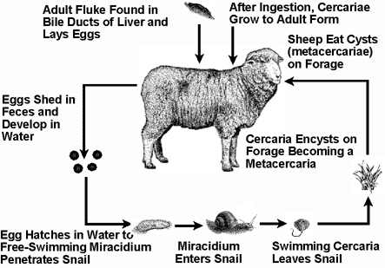
ECONOMIC IMPORTANCE OF LIVEFLUKE
- Destroys the liver tissues
- Causes general weakness of the animal
- Causes obstruction of the bile duct
- It inhibits the production of bile from the liver
- Lipid digestion is impaired
- It prevent the flow of bile from the gall bladder to the small intestine.
- Excessive blood from the liver causes anaemia
- It leads to death in extreme cases.

CONTROL OF LIVERFLUKE
- Control snails on pasture using copper sulphate solution
- Regular deworming of animals
- Rotational grazing
- Avoid grazing near streams.

ROUNDWORM (Ascaris lumbricoides)
It is an elongated, cylindrical, whiteworm which is pointed at both ends. The body is smooth and covered by thick, tough cuticle of few centimeters long.

LIFE CYCLE OF ROUNDWORM
The eggs are fertilized in the female worm and the larva developed within the egg shell. The eggs are deposited in the intestine of pig from where they are passed out with the host faeces into soil where they can remain for years. When the eggs are picked up by pigs either through feeding or drinking, the egg shells are dissolved by digestive enzymes and the young larvae emerges. The larvae then pierces through intestinal wall to the blood, then to the liver, to the heart then to the lungs. From the lungs, then pierce into the mouth and throat of the pig. From the throat, the larva are swallowed through the gullet into the intestine. Here, the larva develop into mature worms and the life cycle is repeated all over again.

ECONOMIC IMPORTANCE OF ROUNDWORM
- Reduce growth of host animals
- High infestation can affect the respiration of host animals.
- Indigestion and constipation
- Loss of appetite and weakness result in death
- Destroy many organs during the migration of young worms.

CONTROL OF ROUNDWORM
- Regular deworming with piperazine drugs
- Good sanitation
- Provide clean and uncontaminated water to the pig.

GENERAL EVALUATION
- State stages of roundworm.
- Discuss the life cycle of roundworm.
- List five examples of endoparasites.
- Distinguish between ecto and endo parasites

READING ASSIGNMENT
Essential Agric Science by O.A. Iwena, Chapter 41, Pages 390 - 395
WEEKEND ASSIGNMENT
1. The following are endoparasites of livestocks except a. insect bug b. roundworm
c. liverfluke d. tapeworm
2. The primary host of tapeworm is a. man b. sheep c. goat d. pig
3. The head of tapewom is otherwise referred to as a. sucker b. scolex c. hook d. anchor
4. The following are economic importance of tapeworm except a. causing reduced growth b. causing indigestion c. causing death d. causing increased weight in animals
5. Which of the following is not a method of preventing diseases? a. quarantine
b. vaccination c. hygiene d. eating too much

THEORY
- Explain briefly 5 economic importance of tapeworm in livestock production.
- Enumerate 5 methods of preventing livestock diseases.

LIVESTOCK ECTO-PARASITES LFE CYCLES
Tick:- This is an ectoparasite of livestock animals. The body is divided into head and abdominal region. It has four pairs of tough leathery integument. It possesses a toothed hypostome used for sucking blood from its host.

LIFE CYCLE OF TICK
The life cycle of most ticks occur in four stages. These include the egg, the larvae, the nymph and the adult stages. Each of the stages normally requires a separate host.

Egg:- After the female tick has sucked blood and fully engorged, it drops from the host, lays its eggs in the ground under grass and dies.

Larvae:- Each egg hatches into a larva with six legs. The larva crawls into the grass and attaches itself to the skin of passing animals or grazing animals. The larva feeds on the blood of the host and later falls to the ground.

Nymphs:- The larvae on the ground moults into nymphs with eight legs. The nymph crawls and attaches itself to a second host. It feeds on the host and later drops on the ground.

Adult:- Nymph on the ground finally moults into an adult tick which crawls into the grass and attaches itself onto a third host animal. If the adult tick is a female, it inserts its mouth to the body of the animal directly and sucks its blood. But, if the adult tick is a male, it does not fix itself to the host but crawls on the skin in search of a female tick to mate with. After mating with the female, the male dies. When the female has sucked enough blood, it falls on the ground, lay its eggs and dies and the whole cycle is repeated.

There is sexual dimorphism (two distinct forms) that is the male is different from the female. While the male tick does not suck blood, the female is blood sucking.
The stages of development of ticks occuring on the host depend on the type of tick. For example, in the three-host tick e.g. Ixodes ricinus, Amblyomma sp, the larvae feed on one host, the nymphs on another and the adult feeds on a third host.
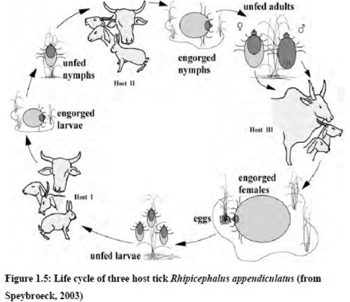
In the two-host tick exemplified Rhipicephalus evertsi (dog tick), the larvae and nymphs develop on the same host while the adult feeds on the second host.

In the one-host tick e.g. Boophilus decoloratus, all the three stages are completed on one individual host.

Methods of Diseases Transmission
The one-host tick transmits disease through the egg, that is, it is transovarian.
The two-host and three-host ticks transmit diseases by infecting their different hosts.

ECONOMIC IMPORTANCE OF TICKS
- They remove or suck appreciable quantities of blood from their host thus leading to anaemia.
- Their bite cause serious skin irritation which may lead to wounds.
- Transmission of diseases such as east coast fever (Theileriasis)
- Damages of skin by tick which reduces the quality of hide.
- Too much loss of blood may lead to loss of weight and death of host animal.

CONTROL OF TICKS
- Keep animals in clean surroundings
- Regular dipping of animals to destroy ticks or spraying with acaricide solution.
- Practice rotational grazing or paddocking.
- Isolation of new stock to ensure they are free from infection.
- Change of animal bedding regularly.
- Handpick ticks from the body of host animals

EVALUATION
- What are ectoparasites?
- State stages of tick.
- Discuss the life cycle of tick.

LICE
These are wingless insects with flattened bodies. They are remarkably specific to their hosts, that is, each species is parasitic on only one kind of animal. The lice of poultry or cattle for instance, cannot live successfully on man and vice versa. The body is divided into three-head, thorax and abdomen. Their bodies are made up of exoskeleton with mouth part used for biting and sucking. They attack cattle, sheep, goat and poultry birds.

LIFE CYCLE OF LICE
All lice pass their life cycle on the surface of the host and they cannot live long away from a host. They attach their eggs called nits to the hair or feather of the host and the young ones called nymphs emerged from the hatched eggs. This is an incomplete metamorphosis. The nymphs after a series of moults of its skin becomes the adult male or female louse. The life cycle takes about three to four weeks.
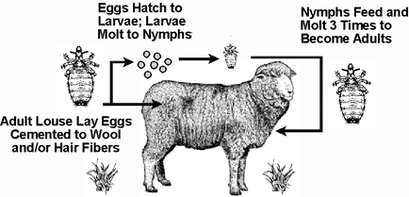
Nymph
Economic importance of lice
- Bites cause considerable irritation which results in scratching and restlessness.
- Scratching may result in sores which may be infested with bacteria
- Restlessness can result in low productivity of the stocks
- They act as vectors of disease
- They suck the blood of host thus leading to anaemia, loss of weight and death.

Mode of Transmission
By body contact

CONTROL OF LICE
- Overcrowding should be avoided to reduce the incidence of contact.
- The parasite can be killed with insecticide.
- Keep animals in clean environment.
- Regular dipping of animals in acaricide solution.

GENERAL EVALUATION
- What are ectoparasites?
- State stages of lice.
- Discuss the life cycle of lice
- List five ectoparsites
- List five endo parasites

READING ASSIGNMENT
Essential Agric Science by O.A. Iwena, Chapter 41, Pages 394 - 396

ASSIGNMENT
1. The following are ectoparasites of livestock except a. tick b. louse c. flea d. roundworm
2. Which of the following is not an endoparasite of livestock? a. Earthworm b. tapeworm c. roundworm d. liverfluke.
3. Attack of lice on animals can be controlled by the following except. a. vaccination
b. dipping c. avoid overcrowding d. spraying with insecticide.
4. Regular sucking of blood of animals by ticks can lead to a disease called a. anaemia
b. trypanosomiasis c. ringworm d. coccidiosis
5. Trypanosomiasis affect the following animals except a. fowl b. goat c. cattle d. sheep

THEORY
- Describe briefly the life history of tick.
- Compare and contrast the features of ticks and lice.

EVALUATION
- List 5 economic importance of tapeworm
- What are parasites
- List five economic importance of roundworm
- List five economic importance of tapeworm
- Explain how to control tapeworm
- Explain how to control round worm.

WEEKEND ASSIGNMENT
- Which of these livestock parasites possesses proglottides? a) liver fluke b) roundworm c) tapeworm d) trypanosome e) tick
- The water snail is important in the life cycle of a) roundworm b) tapeworm c) liverfluke d) coccidium e) tick
- When a farmer tries to eradicate snails from his pastures, he is attempting to to control a) ticks b) tapeworms c) trypanosomiasis d) liver flukes,
- Liverflukes infestation causes disturbance in lipid digestion because it a) blocks the passage of fat to intestine b) blocks the bile duct and reduces secretion of bile
c) destroys the lipase enzyme d) prevents fat excretion.
- Diseases of animals that can be transferred to humans are a) nutritional
b) physiological c) zoonotic d) parasitic

THEORY
- List 5 economic importance of tapeworm
- List 5 economic importance of roundworm

GENERAL EVALUATION
- List 5 economic importance of lice
- What are parasites?
- List five endo parasites.
- How can lice be controlled?
- How can tick be controlled?

WEEKEND ASSIGNMENT
- The brownish, flattened and leaf like parasites found in cattle are called a) tapeworms b) liverflukes c) ticks d) roundworms e) lice
- Which of these livestock diseases is transmitted by ticks? A) red water b) Coccidiosis c) Aspergilosis d) trypanosomiasis e) Brucelliosis
- The commonest ectoparasite of birds are a) lice b) fleas c) mites d) ticks d) houseflies
- An unproductive animal completely removed from the rest of the stock is said to be a) quarantined b) culled c) isolated d) confined e) sold.
- What type of pasture practice is used for controlled parasite vector a) overgazing b) zero-grazing b) rotational grazing c) reseeding

THEORY
- List five economic importance of tick
- List five economic importance of lice

EVALUATION
- List three controls of Lice
- What is animal disease?
- What are pathogens?
- List five disease causing organism.
- How can you control ticks
- List four economic importance of tick.

WEEKEND ASSIGNMENT
- The most effective method of controlling ectoparasites in farm animals is by regular a)exposure of animals to sunlight b)dipping of animals in a solution of pesticides c) handpicking of ectoparasites d)isolation of infested animals.
- The purpose of vaccination is to a) treat parasites infestation b) prevent disease infection c)control parasites d)treat diseases.
- The following are practical measures of controlling trypanosomiasis except a)spraying against the vector b)modification of vector’s habitat c)use of drug on diseased livestock d)vaccinatings against trypanosomes.
- All these are controls of parasites in piggery except a) disinfecting pens b) regular cleaning of feed and water troughs c) isolating sick animals d) weekly vaccination of pigs
- The commonest endoparasite of pig are a)lice b)tapeworm c)mites d)ticks d)roundworm

THEORY
- List 4 controls of Lice
- List 4 controls of tapeworm

